##### ***Book Rental System Investigory Project***



**Department of Computer Science and Engineering**

**Year: 2016-17**

**CSE-9 GROUP-B**

**Submitted by:**

**Anchal Malik – 16BCS1828**

**INTRODUCTION**

We developed this project to book a car on rent at the fare charges. In present system all booking work done manually and it takes very hard work to maintain the information of booking and cars. If you want to find which vehicle is available for booking then it takes a lot of time. It only makes the process more difficult and hard. This aim of the project is to automate the work performed in the car rental management system like generating daily bookings, records of car or cab available for booking, record of routes available, rental charges for cars for every rout, store record of the customer.  
Car rental management system is a car booking software that provides a complete solution to all your day-to-day car booking office running needs. This system helps you to keep the information of Customer online. You can check your customer information any time by using this system. Cab rental management system is a unique and innovative product. Using this this you can also keep the information of number of bookings in current month or in last 6 month or in last year. This helps you to track your business and you earning in particular month or in any year. Based on this information you can take decision regarding your business development.

**This system gives following features to the customers**  
  
Registration: in this system user have to become a registered user to rent a car. User have to fill up his contact information like his name, address, mobile number in the registration form. After submitting the form he get username and password to login the system.  
  
Date Scheduling: use can select the date of car booking. To book a car on selected date he have to give pick up place information and drop off place information.  
  
Booking Confirmation by SMS or email: when your car booking is confirmed then you will get a confirmation message on you given mobile number. In this message, you will also get the amount that you paid for the booking.  
  
Choose Preferred Route through the application: user can also check the available routs for his journey and he can select his preferred route from the car rental system.  
  
Prepaid and Postpaid facility: this car rental system give two option to pay the amount for our service. First he can prepaid the amount to rent a car or he can give this rent after taking our service.  
  
You can pay using debit or credit cards or you can also pay by cash for our service. Our car rental system also provide back up facility to reduce the risk of system failure or loss of data. Customer also get instant E-Receipt through your mobile application. Our system also give facility of panic Button for emergency purpose. This increase the security of the customer and he can trust on our service.  
  
Our car rental management system provides a total solution to the field of auto rental industry. The idea behind the proposed website is to develop a system that allows customers to rent any vehicle as per their needs on the selected date for required time and in any of the selected cities.

This service will work 24x7. This system works online so allow anyone to book or rent a vehicle in a city without any time restriction. This system allows the customer to board the vehicle at his choice of location, pay for the rental online and could provide valuable feedback for improvement in services.  With the help of a car rental management system you can maximize the revenue by increasing your reach to customers. user can also keep the detail of car route. Using car rental system your customer can view the routs and fare for that routs. It helps him to take decision of hiring a car for their journey. By using it your customers will be able to get estimate quotes, see estimated fare summary and make Car online reservations from your website, with just a few clicks. this system also keep the information of cancellation and modification of booking in current month. This facility take the admin control over booking of the car as he can cancel the car booking if car is not available or there is some issue in booking a particular car booking. This system also helps the administrator to check the business of the company.

Our car booking system provide following facilities to out customer  
  
Pickup and drop-off locations according to choice  
  
Vendor details of each vehicle  
  
Maintaining record of every booking history  
  
Feedback mechanism for increasing service quality   
  
Contact Details of every vendor   
  
Online payment option   
  
Location wise search of vendors   
  
Receipt and online voucher generation

**DATA FLOW DIAGRAM OF BOOK RENTAL MANAGEMENT SYSTEM**

[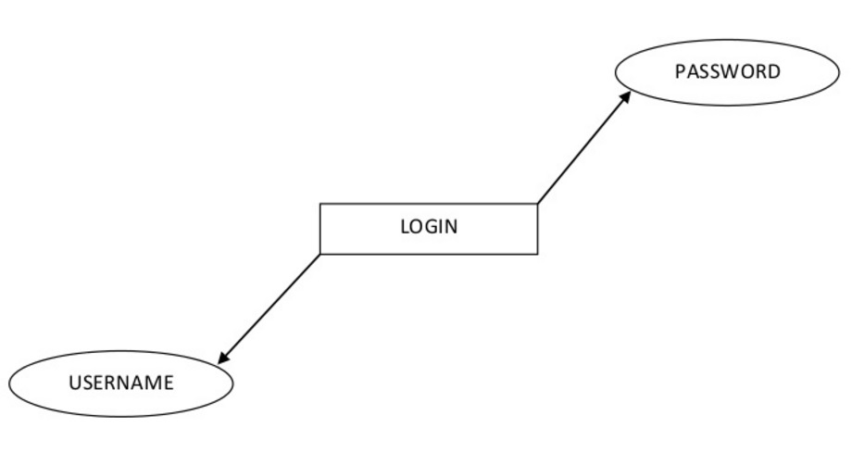](https://sites.google.com/site/ignoubcafinalyearprojects/project-report/online-car-rental-system-project-report/0%20LEVEL%20LOGIN%20DFD%20-%20CAR%20RENTAL%20MANAGEMENT%20SYSTEM.jpg?attredirects=0)

**CUSTOMER DETAILS DFD -**

[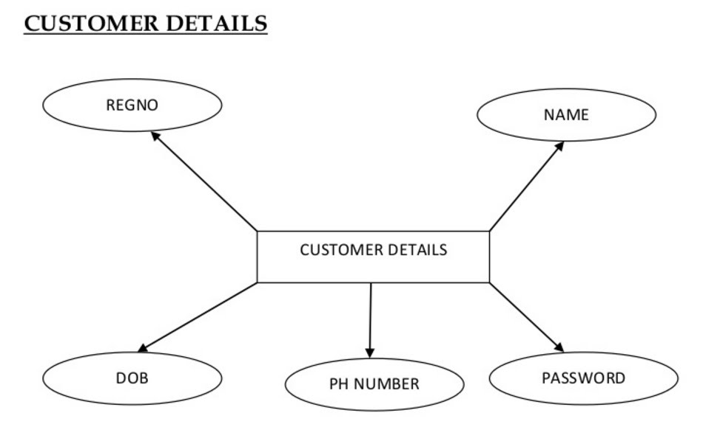](https://sites.google.com/site/ignoubcafinalyearprojects/project-report/online-car-rental-system-project-report/CUSTOMER%20DETAILS%20DFD%20-%20CAR%20RENTAL%20MANAGEMENT%20SYSTEM.jpg?attredirects=0)

**[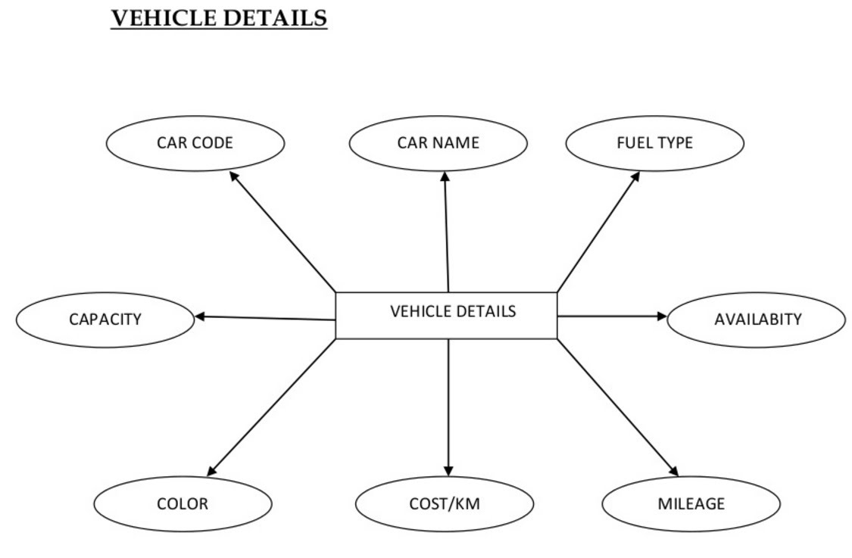](https://sites.google.com/site/ignoubcafinalyearprojects/project-report/online-car-rental-system-project-report/VEHICLE%20DETAILS%20DFD%20-%20CAR%20RENTAL%20MANAGEMENT%20SYSTEM.jpg?attredirects=0)**

**LIBRARIAN DETAILS**

[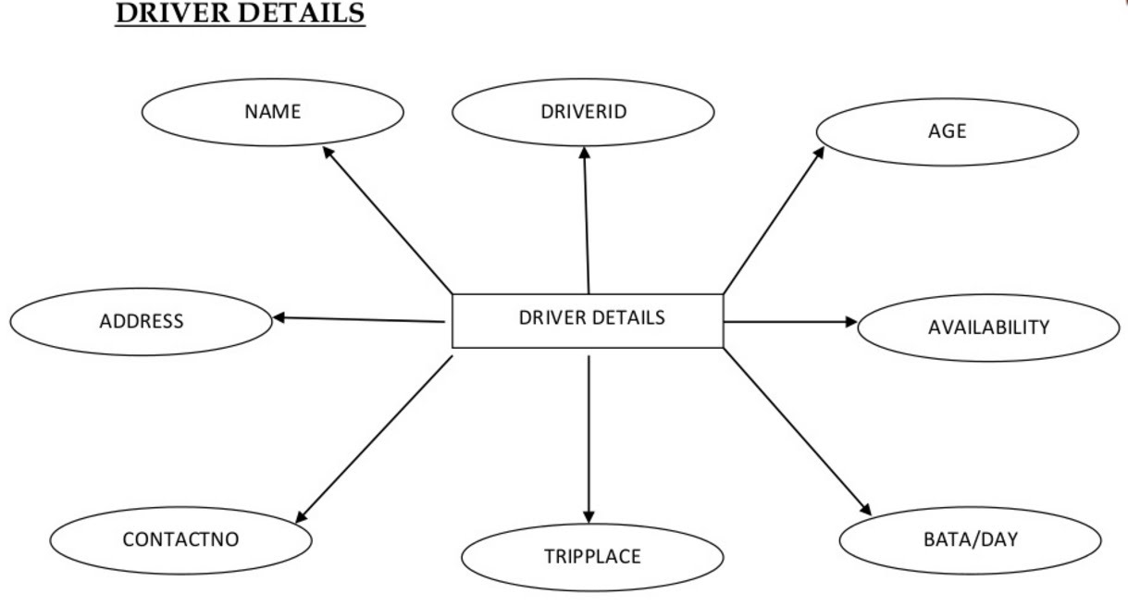](https://sites.google.com/site/ignoubcafinalyearprojects/project-report/online-car-rental-system-project-report/DRIVER%20DETAILS%20DFD%20-%20CAR%20RENTAL%20MANAGEMENT%20SYSTEM.jpg?attredirects=0)

BOOK Rental System is now available at freedownloadbcamcaproject.in was made to buy and sell engineering projects and notes online.  Online Car Rental Project,Ask Latest information, Abstract, Report, Presentation online car rental system project report, car rental project documentation. download vehicle rental system source code in asp.net and project report (documentation) with ppt. online web portal Related Projects. Online Rental System Project. CAR RENTAL SYSTEM System We use in this project Microsoft word for any report Process modeling This project is designed to be used by Car Rental Company. Project Report On Car Sales Project Report On Car Sale Management System: Project Report On Car This is project of a car rental company based.

**TRANSACTION DETAILS**

**[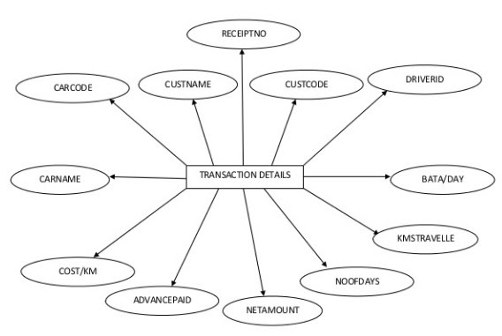](https://sites.google.com/site/ignoubcafinalyearprojects/project-report/online-car-rental-system-project-report/TRANSACTION%20DETAILS%20DFD%20-%20CAR%20RENTAL%20MANAGEMENT%20SYSTEM.jpg?attredirects=0)**

reasons, they would also have to sign a form for them taking a book out. The assistant would ask how long they would like to borrow it and stamp it on the book and also type it up in our files. If the security question is not answered wrong the assistant would not get the card back unless they bring proof so show there self.   
  
When the member returns the book the assistant would go to the computer and delete it from the books that should be bought back. In the book the date is crossed out and replaced in the shelf for the next member. If a book were not bought back a warning letter would be sent out 3 times to remind the member. At the end of the day the assistant would search the computer if any books that are overdue and send a

**Section 1:Problem Description**

Problem Domain Family Book Rentals is a library scheduled to have its official opening in May 23 2008. Construction of the library took place over a period of one year and five months. From currently available information, the library is to have 14,230 books in its collection. (The number of books is not stable as new books are added and outdated articles retire from its collection.) Normal operations of the ibrary depend largely upon the interactions between librarians and registered library users. In order for these interactions to occur smoothly, the two roles need to have the following functionalities Librarians For the library to carry out its daily operations, **librarians** have to register, search, delete and update the status/information about its librarian users. In addition to this, the librarians also have to be able to add, search, delete and update the status/information of the books in belonging to the library. It is also part of the librarian’s duties to add, search, and update charges on the accounts of its users. The librarians should also be able to place books on hold for library users. Registered Library Users **Registered Library Users**

need to have the ability to view the books borrowed, view/update information regarding his/her account, place books on hold, view any outstanding charges and search the library catalogue for books. Current Situation Prior to its opening, the library is in need of a web-based book rental management system to modify/ track the status of its books, its librarians and its registered library users. In its current state, Family Book Rentals does not have a system in place that allows its librarians to perform their functions. As well, its library users are not able to view/update their account information, view the books they borrowed, place books on hold, view any outstanding charges or search the library catalogue for books. It is with this management system that the library will have the ability to track its books, librarians, library users and user charges. As well, this system will allow librarians to perform their duties and allow library users to view/update their account information, view the books they borrowed, place books on hold, view outstanding charges and search the library catalogue for books.

**Section 2:**

**Solution Functionalities** **Needed For the Users of the System Functionalities** for Librarians 1) Add Member 2) Search Member 3) Delete Member 4) Update Member Information 5) Add Book 6) Search Book 7) Delete Book 8) Update Book Status 9) Add Member Charges 10) Search Member Charges 11) Update Member Charges 12) Place Books on Hold Functionalities For the Registered Library User 1) View Books Borrowed 2) View Account Information 3) Update Account Information 4) Place Books on Hold 5) View Outstanding Charges 6) Search Books Data to be Stored Data Regarding Registered Members (Registered Librarian Users): In this book rental system, all customers are registered members. The following pieces of information about each member have to be tracked. 1) Name 2) Social Insurance Number 3) Address 4) Phone 5) Unique ID (Barcode) 6) Age 7) Membership Type 8) Membership Expiry Date 9) Total Number of Rentals (Book Check-Outs) 10) Outstanding Charges 11) Outstanding Rentals (Book Check-Outs) Data Regarding Books In this book rental system, the following pieces of information about each book have to be tracked 1) Name 2) Unique ID (Barcode) 3) Book Status (new/retired) 4) Availability Status (available/ unavailable) Data Regarding Library In this book rental system, the following pieces of information have to be tracked 1) Maximum Number (Capacity) of Books 2) Current Number of Books 3) Current Number of Registered Members 4) Book Overdue Rate 5) Current Librarian Accounts 6) Current Customer Accounts

**Rental Fees**

MoE will set a rental fee nationally either

* per grade or
* per textbook

The fee will apply to all schools throughout the county andschools cannot vary the fee. Richer parents can however provide extra moneys for poor children. Special budgets usually exist at regional level for needy children e.g. for meals, textbooks.

Usually the librarian will be the “accountant” within each school, although responsibility often falls on the class teacher. Larger schools will have a school accountant.

**Variations on rental schemes**

* Central control

Under this method the MoE or more usually, a legally-separate body, will be responsible for textbook ordering, distribution, and rental fee collections.

* Regional control

Regions will take an assessment of local textbook needs and place orders for textbooks. In subsequent years, efficient regions where pupils are motivated to take good care of textbooks e.g. by special covers, will achieve savings as they can order fewer textbooks. The same applies to regions where the population is falling.

Conflicts may exist between textbook provision, help for needy children and other local projects. It is thus difficult to ensure equal treatment in all regions.

* School / PTA control

This is perhaps the ideal but most difficult scheme. Schools and parents have a vested interest in securing economic textbook supply for their children.

**Problems with rental schemes**

To an emerging economy a year is a long time, and 4 years a lifetime. To lock up moneys for up to 4 years is “unproductive” in that it only earns interest rather than being put to use (opportunity cost).

In transition countries, there have been a number of scams whereby citizens have been encouraged to “invest” in a venture for a longer period for ahigh return. In some cases the money has disappeared e.g. the Albania scam which caused national unrest. There is simply not the same regulation to enforce rules and laws.

**Revolving Funds**

Revolving Funds are not a method of financing textbooks. They are only a mechanism, which may work under several of the systems discussed earlier.

The key aims of such a fund are to:

* ensure that moneys are spent for a specific purpose only e.g. textbooks and outside MoE control
* keep special textbook moneys separate from other moneys
* keep textbook moneys separate and outside budget moneys
* allows a fund to operate to pre-agreed rules and conditions under an appointed independent board
* give confidence
* to suppliers e.g. publishers that they will be paid if they fulfill their contracts. Payments are made on results not on the basis of advance payments prior to delivery
* to “customers” e.g. schools, pupils that their money is safe and can be used only for the agreed purpose
* to other citizens by publishing public accounts

Revolving and similar funds give confidence to donor agencies that moneys will be used for the purpose intended under independent control.

A typical aid-funded rental scheme

(100% donor funding)

|  |  |  |  |  |
| --- | --- | --- | --- | --- |
| **Stage** | | **Operation** | | **Comment** |
| 1 | | MoE via MoF and donor agree loan and assistance contract | | These usually take a number of years to evelop and negotiate despite the urgency for textbooks |
| 2 | | Approval of new curriculum, syllabi | | The most important and most time-consuming element. Many governments want funding simply for reprints |
| 3 | | Commissioning of manuscripts usually through publishers on a monopoly or competitive basis | | Most publishers will use existing authors in order to get their textbooks accepted |
| 4 | | Contracts awarded to publiser(s) | | Publishers will usually be contracted to be responsible for commissioning, printing and paper |
| 5 | | Textbook distribution | | Publishers may be responsible or special distributor(s) appointed by MoE |
| 6 | | Payment to publishers and distributors | | Publishers and / or distributors will usually be paid against proof of delivery, rather than through the stage payments |
| 7 | | Receipt by schools or pupils | | Either   * schools take delivery * parents buy via bookshops * PTA’s take delivery |
| 8 | | Textbooks are rented to pupils | | Librarian or class teacher issues textbooks, collect rental fees. Schools or municipality may have a local budget for needy children |
| 9 | | Rental fees are banked | | Either into a single national account, school sub-account, or PTA account |
| 10 | | Textbooks are collected at the end of school year | | Textbooks are stored in the school library awaiting the next year’s pupils. Fines may be levied for lost or damaged textbooks |
| 11 | | Start of the school year – year 2 | | Textbooks are reissued to new pupils; problems may exist concerning changes in the class number, different subject choices in certain later grades.  Year three follows the same cycle |
| 12 | | End of school year – year 4 | | Textbooks are collected up. Textbooks in good condition can be used for subsequent years |
| 13 | Revolving fund has amassed enough funds for reprints | | A revolving fund with a single national account, or sub-account for each school, or at PTA’s has accumulated sufficient funds for reprints required for the following school year and beyond | |
| 14 | New textbooks are introduced each year until all school grades have newly written textbooks | | Textbooks may be introduced simultaneously for e.g. grades 2 and 4 etc. for primary grades | |

Textbooks may be rented for less than four years but

* The rental fee will have to be higher or
* The donor loan will be higher

**Calculation of Rental Fees**

The aim is to accumulate sufficient funds to pay for subsequent reprints so textbooks are self-financing from the MoE’s point of view. The fee must be affordable to nearly all pupils.

|  |  |
| --- | --- |
| **Textbook rental assumptions** |  |
| Textbook rental fee in say US cents | 42 |
| Wastage per year | 10% |
| Inflation year 4 | 20 |
| Textbook unit cost in US cents | 100 |
| Number of textbooks printed | 140 |

Analysis

|  |  |  |
| --- | --- | --- |
| **Year** | **Item** | **Value** |
| 0 | Payment for books by donor loan | -140 |
| 1 | Rental Fee | 42 |
| 2 | Rental Fee | 42 |
| 3 | Rental Fee | 42 |
| 4 | Rental Fee | 42 |
| 4 | Amount in Fund | 168 |
| 4 | Payment for textbooks from Fund | 168 |

Thus 168 in local currency is collected to pay 168 in local currency in year 4 such the system is self-financing.

In practice the system is more complex due to inflation, needy children, and the desire by governments to borrow as little as possible and to charge low rental fees. In theory a Fund needs only to hold enough money for the following year’s textbooks but not in practice. Schemes can be for periods of less than 4 years rental.

Other areas for investigation

The notes so far focus on compulsory primary education. Secondary education tends to receive less attention as it is often not compulsory and benefits fewer pupils.

**Mark-ups**

Every supplier is marking up a margin on his or her own costs. Inflation thus tends to benefit certain parties e.g. authors. Under the Soviet model suppliers wouldusually add 20% to their costs. Printers mark-up paper costs and further mark-up their total costs. Most Western printers would mark-up by say 10% with very little on paper. Paper prices are controlled and often higher than in Western Europe due to lack of competition, import duties, freight costs.

The high mark-upsresult from the past but there is no reason for such highmark-ups except for the lack of true competition. When calculated in terms of returnon capital, textbooks are very rewarding financially for publishers. Except for the pre-press stages, the cashflow cycle is short.

**Author contracts**

In many countries a fixed royaltyis paid based on theselling price, regardless of the print run. Textbooks print runs are very high and there is often no real selling price. A net receipt basis or fee would be more appropriate from the financial point of view (authors might disagree!). Where MoE purchases the textbooks, it will often pay the same price as in bookshops.

|  |
| --- |
|  |

**JAVA CODE:**

**import** java.util.*;

**public** **class** bookstore

{

Scanner obj=**new** Scanner(System.*in*);

**int** p=1,q=1,r=1,s=0,t=0;

String name1=" ",name2=" ";

**int** count=0,rate3=0,rate4=0;

**int** rate1=4,rate2=3,rate0=5;

**public** **void** viewbook1()

{

System.*out*.println("THE AVAILABLE BOOKS ARE ");

**if**(p==1)

System.*out*.println("1-Java Complete Reference * rating = "+rate0);

**if**(q==1)

System.*out*.println("2-Java Sun Microsystems * rating = "+rate1);

**if**(r==1)

System.*out*.println( "3-Java Khalid Mughal * rating = "+rate2);

**if**(s==1)

System.*out*.println("4-"+name1+" * rating ="+rate3);

**if**(t==1)

System.*out*.println("5-"+name2+" * rating ="+rate4);

}

**public** **void** viewbook()

{

System.*out*.println("THE AVAILABLE BOOKS ARE THERE TO BE ISSUED SELECT NUMBER TO TAKE");

**if**(p==1)

System.*out*.println("1-Java Complete Reference * rating = "+rate0);

**if**(q==1)

System.*out*.println("2-Java Sun Microsystems * rating = "+rate1);

**if**(r==1)

System.*out*.println( "3-Java Khalid Mughal * rating = "+rate2);

**if**(s==1)

System.*out*.println("4-"+name1+" * rating ="+rate3);

**if**(t==1)

System.*out*.println("5-"+name2+" * rating ="+rate4);

**int** response=obj.nextInt();

issuebook(response);

}

**public** **void** Addbook()

{

System.*out*.println("WELCOME TO ADD BOOK SECTION");

System.*out*.println("ENTER NAME AND RATING OF THE BOOK");

String str=obj.next();

**int** a=obj.nextInt();

**if** (count==0)

{

name1=str;

count++;

rate3=a;

s=1;

System.*out*.println(" BOOK ADDED SUCCESSFULLY");

}

**else** **if**(count==1)

{

name2=str;

rate4=a;

t=1;

System.*out*.println(" BOOK ADDED SUCCESSFULLY");

}

}

**public** **void** issuebook(**int** esponse)

{

**if**(esponse==1)

{

System.*out*.println("ISSUED HANDLE WITH CARE AND RETURN SOON");

p=0;

}

**if**(esponse==2)

{

System.*out*.println("ISSUED HANDLE WITH CARE AND RETURN SOON");

q=0;

}

**if**(esponse==3)

{

System.*out*.println("ISSUED HANDLE WITH CARE AND RETURN SOON");

r=0;

}

**if**(esponse==4)

{

System.*out*.println("ISSUED HANDLE WITH CARE AND RETURN SOON");

s=0;

}

**if**(esponse==5)

{

System.*out*.println("ISSUED HANDLE WITH CARE AND RETURN SOON");

t=0;

}

}

**public** **void** rcvbook()

{

System.*out*.println("select book number to return the book");

System.*out*.println("1-Java Complete Reference * rating = "+rate0);

System.*out*.println("2-Java Sun Microsystems * rating = "+rate1);

System.*out*.println( "3-Java Khalid Mughal * rating ="+rate2);

**if**(s==1)

System.*out*.println("4-"+name1+" * rating ="+rate3);

**if**(t==1)

System.*out*.println("5-"+name2+" * rating ="+rate4);

**int** sponse=obj.nextInt();

**if**(sponse==1)

{

System.*out*.println("COLLECTED SUCCESFULLY THANKS FOR RETURNING");

p=1;

}

**if**(sponse==2)

{

System.*out*.println("COLLECTED SUCCESFULLY THANKS FOR RETURNING");

q=1;

}

**if**(sponse==3)

{

System.*out*.println("COLLECTED SUCCESFULLY THANKS FOR RETURNING");

r=1;

}

**if**(sponse==4)

{

System.*out*.println("COLLECTED SUCCESFULLY THANKS FOR RETURNING");

s=1;

}

**if**(sponse==5)

{

System.*out*.println("COLLECTED SUCCESFULLY THANKS FOR RETURNING");

t=1;

}

}

**public** **void** ratebook()

{

**int** c=1,c1=1,c2=1,c3=1,c4=1;

System.*out*.println("select book number to rate the book 1 star to 5 star");

System.*out*.println("1 Java Complete Reference #present rating is "+rate0);

System.*out*.println("2 Java Sun Microsystems #present rating is "+rate1);

System.*out*.println( "3 Java Khalid Mughal #present rating is "+rate2);

**if**(s==1)

System.*out*.println("4 "+name1+" #present rating is "+rate3);

**if**(t==1)

System.*out*.println("5 "+name2+" #present rating is "+rate4);

**int** se=obj.nextInt();

**if**(se==1)

{

c++;

**int** temp=obj.nextInt();

temp=rate0+temp;

rate0=temp/c;

System.*out*.println("Thanks for rating");

temp=0;

}

**if**(se==2)

{ c1++;

**int** temp=obj.nextInt();

temp=rate1+temp;

rate1=temp/c1;

System.*out*.println("Thanks for rating");

temp=0;

}

**if**(se==3)

{

c2++;

**int** temp=obj.nextInt();

temp=rate2+temp;

rate2=temp/c2;

System.*out*.println("Thanks for rating");

temp=0;

}

**if**(se==4)

{

c3++;

**int** temp=obj.nextInt();

temp=rate3+temp;

rate3=temp/c3;

System.*out*.println("Thanks for rating");

temp=0; }

**if**(se==5)

{ c4++;

**int** temp=obj.nextInt();

temp=rate4+temp;

rate4=temp/c4;

System.*out*.println("Thanks for rating");

temp=0;

}

}

}

**class** launcher **extends** bookstore

{

**public** **void** front()

{

**int** op;

**do**

{

System.*out*.println("WELCOME TO BOOK MANAGER");

System.*out*.println("CHOOSE A TASK TO PERFORM");

System.*out*.println("1 TO BORROW A BOOK FROM STORE");

System.*out*.println("2 TO RETURN BACK A BOOK TO STORE");

System.*out*.println("3 TO RATE A BOOK OF STORE");

System.*out*.println("4 TO ADD A BOOK TO STORE");

System.*out*.println("5 TO SEE BOOKS OF THE STORE");

**int** g=obj.nextInt();

**if**(g==1)

viewbook();

**if**(g==2)

rcvbook();

**if**(g==3)

ratebook();

**if**(g==4)

Addbook();

**if**(g==5)

viewbook1();

System.*out*.println("enter 1 to continue or any other number to exit");

op=obj.nextInt();

}**while**(op==1);

}

**public** **static** **void** main(String[] args)

{

launcher ob= **new** launcher();

ob.front();

}

}

**import** java.util.*;

**public** **class** bookstore

{

Scanner obj=**new** Scanner(System.*in*);

**int** p=1,q=1,r=1,s=0,t=0;

String name1=" ",name2=" ";

**int** count=0,rate3=0,rate4=0;

**int** rate1=4,rate2=3,rate0=5;

**public** **void** viewbook1()

{

System.*out*.println("THE AVAILABLE BOOKS ARE ");

**if**(p==1)

System.*out*.println("1-Java Complete Reference * rating = "+rate0);

**if**(q==1)

System.*out*.println("2-Java Sun Microsystems * rating = "+rate1);

**if**(r==1)

System.*out*.println( "3-Java Khalid Mughal * rating = "+rate2);

**if**(s==1)

System.*out*.println("4-"+name1+" * rating ="+rate3);

**if**(t==1)

System.*out*.println("5-"+name2+" * rating ="+rate4);

}

**public** **void** viewbook()

{

System.*out*.println("THE AVAILABLE BOOKS ARE THERE TO BE ISSUED SELECT NUMBER TO TAKE");

**if**(p==1)

System.*out*.println("1-Java Complete Reference * rating = "+rate0);

**if**(q==1)

System.*out*.println("2-Java Sun Microsystems * rating = "+rate1);

**if**(r==1)

System.*out*.println( "3-Java Khalid Mughal * rating = "+rate2);

**if**(s==1)

System.*out*.println("4-"+name1+" * rating ="+rate3);

**if**(t==1)

System.*out*.println("5-"+name2+" * rating ="+rate4);

**int** response=obj.nextInt();

issuebook(response);

}

**public** **void** Addbook()

{

System.*out*.println("WELCOME TO ADD BOOK SECTION");

System.*out*.println("ENTER NAME AND RATING OF THE BOOK");

String str=obj.next();

**int** a=obj.nextInt();

**if** (count==0)

{

name1=str;

count++;

rate3=a;

s=1;

System.*out*.println(" BOOK ADDED SUCCESSFULLY");

}

**else** **if**(count==1)

{

name2=str;

rate4=a;

t=1;

System.*out*.println(" BOOK ADDED SUCCESSFULLY");

}

}

**public** **void** issuebook(**int** esponse)

{

**if**(esponse==1)

{

System.*out*.println("ISSUED HANDLE WITH CARE AND RETURN SOON");

p=0;

}

**if**(esponse==2)

{

System.*out*.println("ISSUED HANDLE WITH CARE AND RETURN SOON");

q=0;

}

**if**(esponse==3)

{

System.*out*.println("ISSUED HANDLE WITH CARE AND RETURN SOON");

r=0;

}

**if**(esponse==4)

{

System.*out*.println("ISSUED HANDLE WITH CARE AND RETURN SOON");

s=0;

}

**if**(esponse==5)

{

System.*out*.println("ISSUED HANDLE WITH CARE AND RETURN SOON");

t=0;

}

}

**public** **void** rcvbook()

{

System.*out*.println("select book number to return the book");

System.*out*.println("1-Java Complete Reference * rating = "+rate0);

System.*out*.println("2-Java Sun Microsystems * rating = "+rate1);

System.*out*.println( "3-Java Khalid Mughal * rating ="+rate2);

**if**(s==1)

System.*out*.println("4-"+name1+" * rating ="+rate3);

**if**(t==1)

System.*out*.println("5-"+name2+" * rating ="+rate4);

**int** sponse=obj.nextInt();

**if**(sponse==1)

{

System.*out*.println("COLLECTED SUCCESFULLY THANKS FOR RETURNING");

p=1;

}

**if**(sponse==2)

{

System.*out*.println("COLLECTED SUCCESFULLY THANKS FOR RETURNING");

q=1;

}

**if**(sponse==3)

{

System.*out*.println("COLLECTED SUCCESFULLY THANKS FOR RETURNING");

r=1;

}

**if**(sponse==4)

{

System.*out*.println("COLLECTED SUCCESFULLY THANKS FOR RETURNING");

s=1;

}

**if**(sponse==5)

{

System.*out*.println("COLLECTED SUCCESFULLY THANKS FOR RETURNING");

t=1;

}

}

**public** **void** ratebook()

{

**int** c=1,c1=1,c2=1,c3=1,c4=1;

System.*out*.println("select book number to rate the book 1 star to 5 star");

System.*out*.println("1 Java Complete Reference #present rating is "+rate0);

System.*out*.println("2 Java Sun Microsystems #present rating is "+rate1);

System.*out*.println( "3 Java Khalid Mughal #present rating is "+rate2);

**if**(s==1)

System.*out*.println("4 "+name1+" #present rating is "+rate3);

**if**(t==1)

System.*out*.println("5 "+name2+" #present rating is "+rate4);

**int** se=obj.nextInt();

**if**(se==1)

{

c++;

**int** temp=obj.nextInt();

temp=rate0+temp;

rate0=temp/c;

System.*out*.println("Thanks for rating");

temp=0;

}

**if**(se==2)

{ c1++;

**int** temp=obj.nextInt();

temp=rate1+temp;

rate1=temp/c1;

System.*out*.println("Thanks for rating");

temp=0;

}

**if**(se==3)

{

c2++;

**int** temp=obj.nextInt();

temp=rate2+temp;

rate2=temp/c2;

System.*out*.println("Thanks for rating");

temp=0;

}

**if**(se==4)

{

c3++;

**int** temp=obj.nextInt();

temp=rate3+temp;

rate3=temp/c3;

System.*out*.println("Thanks for rating");

temp=0; }

**if**(se==5)

{ c4++;

**int** temp=obj.nextInt();

temp=rate4+temp;

rate4=temp/c4;

System.*out*.println("Thanks for rating");

temp=0;

}

}

}

**class** launcher **extends** bookstore

{

**public** **void** front()

{

**int** op;

**do**

{

System.*out*.println("WELCOME TO BOOK MANAGER");

System.*out*.println("CHOOSE A TASK TO PERFORM");

System.*out*.println("1 TO BORROW A BOOK FROM STORE");

System.*out*.println("2 TO RETURN BACK A BOOK TO STORE");

System.*out*.println("3 TO RATE A BOOK OF STORE");

System.*out*.println("4 TO ADD A BOOK TO STORE");

System.*out*.println("5 TO SEE BOOKS OF THE STORE");

**int** g=obj.nextInt();

**if**(g==1)

viewbook();

**if**(g==2)

rcvbook();

**if**(g==3)

ratebook();

**if**(g==4)

Addbook();

**if**(g==5)

viewbook1();

System.*out*.println("enter 1 to continue or any other number to exit");

op=obj.nextInt();

}**while**(op==1);

}

**public** **static** **void** main(String[] args)

{

launcher ob= **new** launcher();

ob.front();

}

}

**import** java.util.*;

**public** **class** bookstore

{

Scanner obj=**new** Scanner(System.*in*);

**int** p=1,q=1,r=1,s=0,t=0;

String name1=" ",name2=" ";

**int** count=0,rate3=0,rate4=0;

**int** rate1=4,rate2=3,rate0=5;

**public** **void** viewbook1()

{

System.*out*.println("THE AVAILABLE BOOKS ARE ");

**if**(p==1)

System.*out*.println("1-Java Complete Reference * rating = "+rate0);

**if**(q==1)

System.*out*.println("2-Java Sun Microsystems * rating = "+rate1);

**if**(r==1)

System.*out*.println( "3-Java Khalid Mughal * rating = "+rate2);

**if**(s==1)

System.*out*.println("4-"+name1+" * rating ="+rate3);

**if**(t==1)

System.*out*.println("5-"+name2+" * rating ="+rate4);

}

**public** **void** viewbook()

{

System.*out*.println("THE AVAILABLE BOOKS ARE THERE TO BE ISSUED SELECT NUMBER TO TAKE");

**if**(p==1)

System.*out*.println("1-Java Complete Reference * rating = "+rate0);

**if**(q==1)

System.*out*.println("2-Java Sun Microsystems * rating = "+rate1);

**if**(r==1)

System.*out*.println( "3-Java Khalid Mughal * rating = "+rate2);

**if**(s==1)

System.*out*.println("4-"+name1+" * rating ="+rate3);

**if**(t==1)

System.*out*.println("5-"+name2+" * rating ="+rate4);

**int** response=obj.nextInt();

issuebook(response);

}

**public** **void** Addbook()

{

System.*out*.println("WELCOME TO ADD BOOK SECTION");

System.*out*.println("ENTER NAME AND RATING OF THE BOOK");

String str=obj.next();

**int** a=obj.nextInt();

**if** (count==0)

{

name1=str;

count++;

rate3=a;

s=1;

System.*out*.println(" BOOK ADDED SUCCESSFULLY");

}

**else** **if**(count==1)

{

name2=str;

rate4=a;

t=1;

System.*out*.println(" BOOK ADDED SUCCESSFULLY");

}

}

**public** **void** issuebook(**int** esponse)

{

**if**(esponse==1)

{

System.*out*.println("ISSUED HANDLE WITH CARE AND RETURN SOON");

p=0;

}

**if**(esponse==2)

{

System.*out*.println("ISSUED HANDLE WITH CARE AND RETURN SOON");

q=0;

}

**if**(esponse==3)

{

System.*out*.println("ISSUED HANDLE WITH CARE AND RETURN SOON");

r=0;

}

**if**(esponse==4)

{

System.*out*.println("ISSUED HANDLE WITH CARE AND RETURN SOON");

s=0;

}

**if**(esponse==5)

{

System.*out*.println("ISSUED HANDLE WITH CARE AND RETURN SOON");

t=0;

}

}

**public** **void** rcvbook()

{

System.*out*.println("select book number to return the book");

System.*out*.println("1-Java Complete Reference * rating = "+rate0);

System.*out*.println("2-Java Sun Microsystems * rating = "+rate1);

System.*out*.println( "3-Java Khalid Mughal * rating ="+rate2);

**if**(s==1)

System.*out*.println("4-"+name1+" * rating ="+rate3);

**if**(t==1)

System.*out*.println("5-"+name2+" * rating ="+rate4);

**int** sponse=obj.nextInt();

**if**(sponse==1)

{

System.*out*.println("COLLECTED SUCCESFULLY THANKS FOR RETURNING");

p=1;

}

**if**(sponse==2)

{

System.*out*.println("COLLECTED SUCCESFULLY THANKS FOR RETURNING");

q=1;

}

**if**(sponse==3)

{

System.*out*.println("COLLECTED SUCCESFULLY THANKS FOR RETURNING");

r=1;

}

**if**(sponse==4)

{

System.*out*.println("COLLECTED SUCCESFULLY THANKS FOR RETURNING");

s=1;

}

**if**(sponse==5)

{

System.*out*.println("COLLECTED SUCCESFULLY THANKS FOR RETURNING");

t=1;

}

}

**public** **void** ratebook()

{

**int** c=1,c1=1,c2=1,c3=1,c4=1;

System.*out*.println("select book number to rate the book 1 star to 5 star");

System.*out*.println("1 Java Complete Reference #present rating is "+rate0);

System.*out*.println("2 Java Sun Microsystems #present rating is "+rate1);

System.*out*.println( "3 Java Khalid Mughal #present rating is "+rate2);

**if**(s==1)

System.*out*.println("4 "+name1+" #present rating is "+rate3);

**if**(t==1)

System.*out*.println("5 "+name2+" #present rating is "+rate4);

**int** se=obj.nextInt();

**if**(se==1)

{

c++;

**int** temp=obj.nextInt();

temp=rate0+temp;

rate0=temp/c;

System.*out*.println("Thanks for rating");

temp=0;

}

**if**(se==2)

{ c1++;

**int** temp=obj.nextInt();

temp=rate1+temp;

rate1=temp/c1;

System.*out*.println("Thanks for rating");

temp=0;

}

**if**(se==3)

{

c2++;

**int** temp=obj.nextInt();

temp=rate2+temp;

rate2=temp/c2;

System.*out*.println("Thanks for rating");

temp=0;

}

**if**(se==4)

{

c3++;

**int** temp=obj.nextInt();

temp=rate3+temp;

rate3=temp/c3;

System.*out*.println("Thanks for rating");

temp=0; }

**if**(se==5)

{ c4++;

**int** temp=obj.nextInt();

temp=rate4+temp;

rate4=temp/c4;

System.*out*.println("Thanks for rating");

temp=0;

}

}

}

**class** launcher **extends** bookstore

{

**public** **void** front()

{

**int** op;

**do**

{

System.*out*.println("WELCOME TO BOOK MANAGER");

System.*out*.println("CHOOSE A TASK TO PERFORM");

System.*out*.println("1 TO BORROW A BOOK FROM STORE");

System.*out*.println("2 TO RETURN BACK A BOOK TO STORE");

System.*out*.println("3 TO RATE A BOOK OF STORE");

System.*out*.println("4 TO ADD A BOOK TO STORE");

System.*out*.println("5 TO SEE BOOKS OF THE STORE");

**int** g=obj.nextInt();

**if**(g==1)

viewbook();

**if**(g==2)

rcvbook();

**if**(g==3)

ratebook();

**if**(g==4)

Addbook();

**if**(g==5)

viewbook1();

System.*out*.println("enter 1 to continue or any other number to exit");

op=obj.nextInt();

}**while**(op==1);

}

**public** **static** **void** main(String[] args)

{

launcher ob= **new** launcher();

ob.front();

}

}